Here’s a brief outline of the steps for recording video from within Minutes:

- Camera Preview should be available. Start the encoder if needed and confirm that the AV preview is successful.
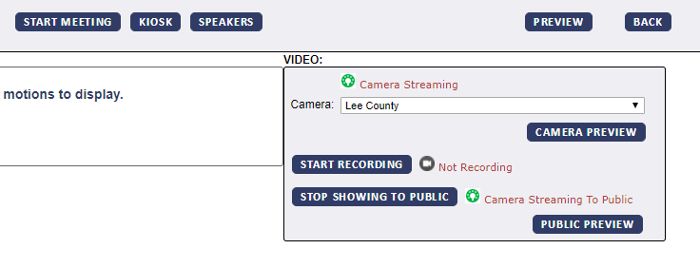
- Start Meeting
- Start Recording
- (Indexing can be completed live during the meeting, or after the meeting has been marked completed.)
- Stop Recording. This will pause the recording (ex: during recess) and can be restarted again as needed throughout the same meeting.
- Close Meeting or mark Video Completed, below. A prompt will be given that this will finalize the video and no additional recordings can be completed at this point.

