Creating a New Agenda Type/Meeting Type

- Support Site (Client.novusagenda.com/support/support.aspx)
- Agenda Types
- Add Agenda Type
  - Input name of new agenda type
  - Copy templates (from a similar already setup agenda)
  - Copy categories checkbox (only if new agenda type categories are similar, time saving)
- Add or Edit the categories in the Agenda Categories table (if different from the copied)
  - Ordinal Value – the way the categories will show up in the dropdown box when end user is creating an item. All 0’s will put them in alpha order.
- Lookup Tables – Add meeting type
  - This should be similar to the agenda type name but with “Meeting” in it, look at other meeting types and follow standard.
- Agenda Types – Meeting Assignment, select meeting and assign
  - This is where you are assigning the meeting type to the agenda type
- IDP Builder
  - Go To Layout Builder
  - 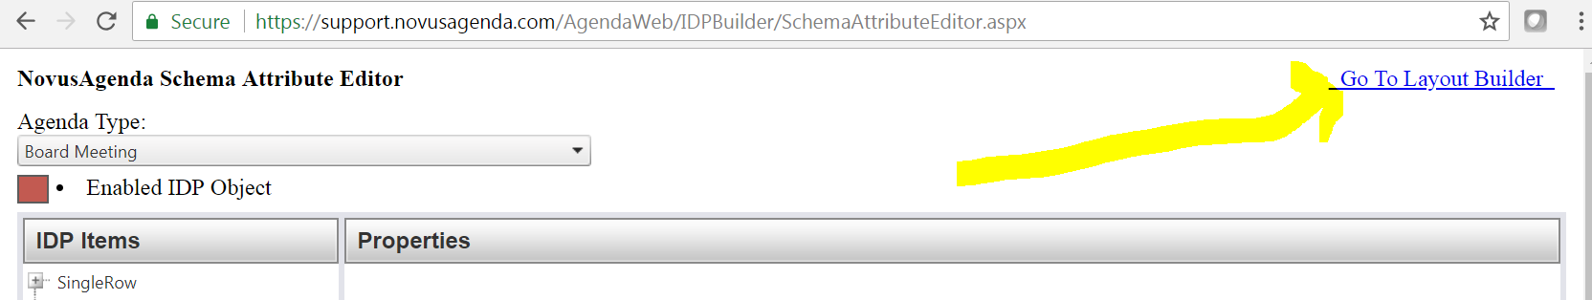
  - Find similar IDP and Copy this layout to… Execute Copy
    - All should match but sometimes they do not
    - Ex: Client has Planning meeting type that uses completely different IDP setup
    - Click through a few and see that they match or are close, then decide. Ask client if unsure.
  - 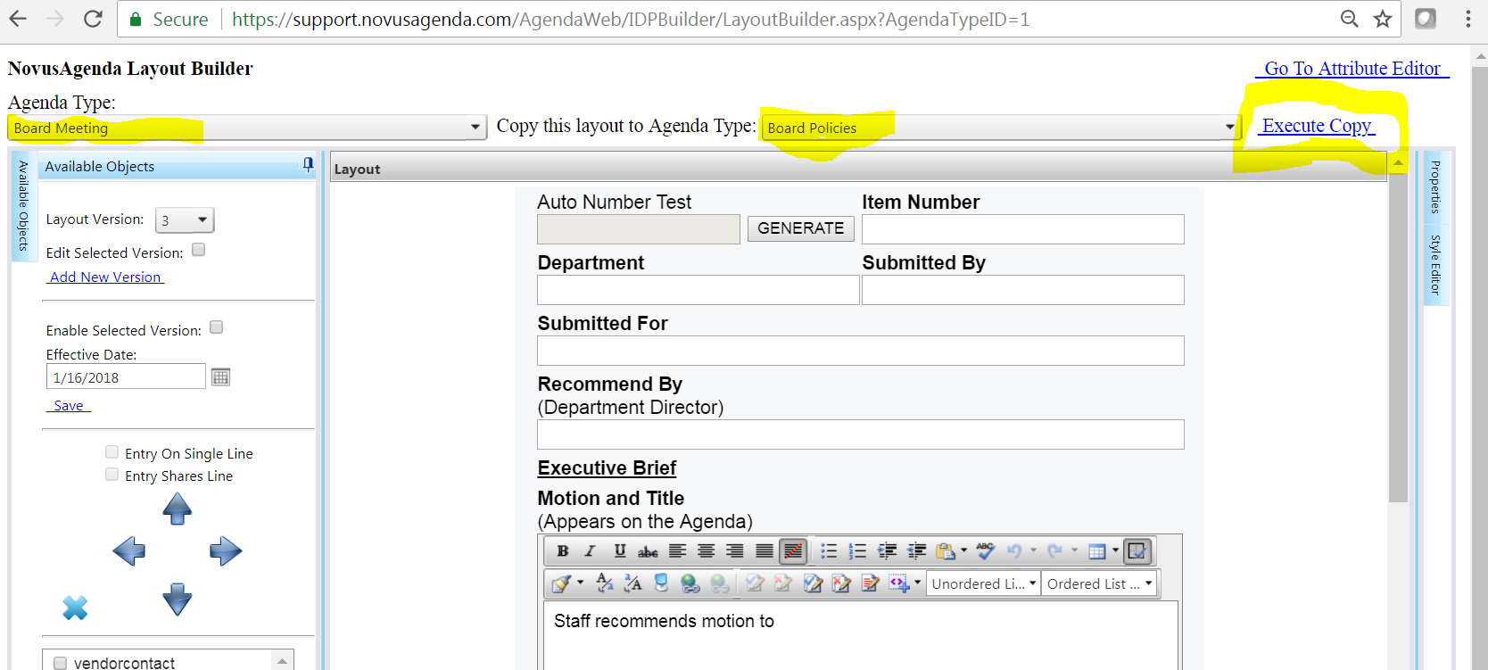

  - Click “Enable Selected Version” and save.
    - NOTE: Effective date is the Item Created Date.
- Template Builder
  - Copy Coversheet from another already created agenda type to the new, making sure to review for any static text such as the meeting type name.
  - Copy templates down from the same meeting type you used to copy categories.
  - Go into each Item repeater and category repeater and set the proper categories.
    - This resets when you copy the agenda, very important part to check!
  - Change heading and any other static text, if needed.
  - If you cannot copy another one, create from scratch
    - Add New Verion
    - Setup Layout block, Style Block and Stitch block
    - Add first RTE for heading, add Category block, add Item repeater, add Motion Repeater
    - Check to ensure it looks good (next steps first if previewing) and copy this one down making it easier to create the rest of the repeaters.
- Application side
  - Create a voting department
  - Create a voting group
  - Assign Voting Group to Voting Department
  - Open each department and add this new agenda type to them, depending on clients needs/request
    - Normally the client wont request this so just use best judgement.
      - If all other agenda types are added to all departments, add the new one
      - If its hit or miss and not obvious, ask the client who should have access
  - Click “Users” and use dropdown to search for all AgendaClerk users
    - Add each agenda clerk into the new meeting using same judgement as above
  - Create a new meeting and test your work
  - Click Configuration, Agenda Types Tab, Dropdown for AgendaType and pick your newly created one.
    - Ensure “Show on Public Calendar” is not checked (unless client request or all others are like this)

