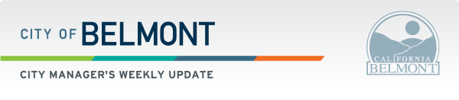

Calendar items:
» May 11, 2021, City Council Special Meeting (Housing Element Update Study Session) [agenda]
» May 11, 2021, City Council Regular Meeting [agenda]
» Friday's - Free Covid testing - Belmont Sports Complex [details]
» Coffee and donuts with Belmont Police (age 60+) details below

COVID-19 Resources
Are you a renter at risk of eviction due to financial hardships caused by #COVID19? You may be eligible for the CA COVID-19 Rent Relief program. Check your eligibility and apply now at HousingIsKey.com or call 833-430-2122 toll free.
Reminder***The American Rescue Plan Act established the Restaurant Revitalization Fund (RRF) to provide funding to help restaurants and other eligible businesses keep their doors open. This program will provide restaurants with funding equal to their pandemic-related revenue loss up to $10 million per business and no more than $5 million per physical location. Recipients are not required to repay the funding as long as funds are used for eligible uses no later than March 11, 2023.
Application period opened on Monday, May 3, 2021, at noon ET.
See How to apply and more details.
Equity in Vaccine Distribution
A NEW data dashboard is available that monitors equity in vaccine distribution by census tract, Health Equity quartile, vaccine administrator, and county average coverage. This data will help San Mateo County Health to better monitor and target equity in vaccine distribution. See all the information here: https://www.smchealth.org/data-dashboards
Shoreway Sewer Gravity Pipe Installation Project
Silicon Valley Clean Water (SVCW) and their contractor Power Engineering Construction (PEC) are continuing work on their sewer main upgrade project on Shoreway Road. Shoreway road is currently closed for this work from 1355 Shoreway to Cormorant Drive until February 2022, and in front of 145 Shoreway Rd until June 2021. Working hours are 6:30 am to 5:00 pm but the road will be closed 24/7 with traffic control and detours currently in place. Next week, PEC will work on shoring installation and soil improvements.
2020 Street Reconstruction Project
City Contractor O’Grady Paving, Inc. will start potholing to verify utilities and conduct soils sampling at the following locations:

- Sussex Court
- Biddulph Way
- Wessex Way
- Pine Knoll Drive
- Terrace Drive
- Robin Whipple Way,
- Valerga Drive
- Villa Avenue
- Buena Vista Avenue
North Road Pump Station and Force Main Rehabilitation Project
The city’s contractor continues work on by-pass pumping on North Road at El Camino Real. Traffic control will be in place. Emergency vehicles and residents of the affected area will have access at all times.
Street Division
This week, the Street Division continued prep work for the 2021 Slurry Project on Naughton Ave and Hillcrest Dr. The crew removed 10.5 tons of failed asphalt and replaced with 10.5 tons of new asphalt. They also crack sealed 8,293 ft on Belmont Canyon Road and East Laurel Creek Road.
The Street Division will continue to perform dig outs and crack sealing throughout the City in advance of this project.
Traffic Operations
The Traffic Operations Division continues to replace deteriorated street name guide signs. Street name signs are essential for timely emergency response. Unlike a STOP sign, which we fabricated in bulk, guide signs need to be specially fabricated due to the variation in the sign message.
Street name signs were fabricated by covering an aluminum blank with green vinyl and then applying white vinyl letters. Today, we cover the aluminum blank with white vinyl and then cover it with a green vinyl film that has the street name cut out. This process allows for greater retro reflectivity and longer sign longevity.
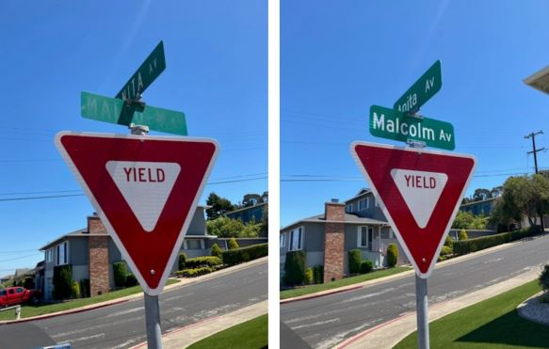
Sewer Division
The Public Works Sewer Division performed preventive maintenance at multiple sewer pump stations this week. Sewer pump station wet wells were cleaned out to remove all debris that sticks to equipment in the wet well. If not removed, this debris builds up over time and interferes with pump control equipment which can cause pump station failure. Mission radio communication equipment is being upgraded to keep the sewer pump stations better connected for remote monitoring.
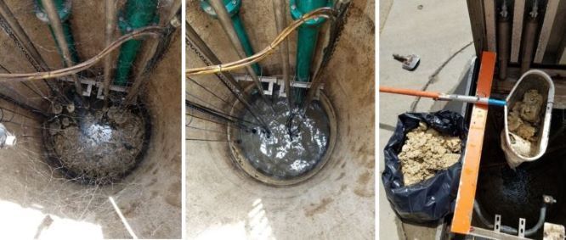
The Public Works Sewer Division is hydro cleaning sewer main lines as routine maintenance at a record high level past two weeks. Since Thursday April 29th, 2021, staff hydro cleaned over 25,000 feet of sewer main line which is about double the average performance. Routine hydro cleaning of sewer main lines has proven to be the most effective tool in preventing sewer overflows. Cleaning the entire system at this fast pace allows us to keep a close eye on the health of the sewer system and determine problem areas that need more attention.
Mother's Day Lunch
A special TEAriffic Mother’s Day senior Grab and Go lunch featured treat bags with tea and cookies to celebrate these special moms. The lunch was a scrumptious offering of beef medallions, cheddar mashed potatoes, a squash medley, salad, bread and fruit. For more information on the Grab and Go Lunch Program, please visit www.belmont.gov/adults or call 650-595-7444.

Coffee & Donuts with the Belmont Police
Belmont Police Department invites senior residents ages 60+ for a “Grab and Go” coffee and a donut on May 26th.
Reservations ARE required for this FREE event :: Phone 595-7444 to reserve your spot and a door prize!
Pick Up Times:
LAST NAMES BEGINNING WITH A—M = 10:00-10:30
LAST NAMES BEGINNING WITH N—Z = 10:30-11:00
Please be Covid-Safe:
• Wear a mask • Stay six feet apart • Stay home if you are not feeling well
May is Older Americans Month!
Join us as the Bay Area Older Adult Recreation Services (OARS) committee comes together, across three counties, to celebrate Older Americans Month virtually. OARS participating cities will be providing a variety of FREE virtual workshops between May 6 - 27. To participate, please look at each workshop's registration information. A link to the listing can be found in www.belmont.gov/adults . We look forward to the celebration across our communities of strength!
BelmontS Photography Contest
We are hosting a photography contest among the four Belmonts from across the nation! (Massachusetts, New Hampshire, North Carolina) Grab your camera and take/share a shot of a connection that's meaningful to you, whichever Belmont you live in. There are 3 diff. categories:
1) Connection with Nature
2) Connection with Others
3) Connection with Self
Submissions due by May 31st, enter here: www.bit.ly/4belmonts

Join us for our final virtual Lotería! This special Mexican version of bingo will include extra trivia about Mexican culture and food. Free to play, and appropriate for all ages, from 5 year-olds to grandparents! The grand prize winner will receive a gift certificate to La Viga Mexican Restaurant. To register, or for more info, go to www.belmont.gov/register and enter “Loteria” in the search bar.

National Safety Month
It is National Building Safety Month, and we have gathered some helpful information to raise awareness for Owners and Builders on building safety. Check out these helpful links.
Building Codes: Driving Growth Through Innovation, Resilience and Safety
10 Important Tips To Remember For Fire Safety and Awareness
The White House Proclamation on National Building Safety Month-2021

Public Recycling Center is Open
Address: 333 Shoreway Road, San Carlos, CA 94070
Phone: (650) 802-8355
Public Hours of Operation:
Monday – Saturday: 8:30 a.m. to 4:00 p.m.
Closed Sundays, Thanksgiving, Christmas, and New Year’s Day
The PRC continues to accept for free drop-off (residential waste only) follow the link for
details https://rethinkwaste.org/shoreway-environmental-center/services/

PG&E Resources
To help customers plan for PSPS events, we have developed a series of educational videos that can be found at:
pge.com/pspsvideos
kidsemergencysafety.com
Additionally, PG&E is hosting webinars for anyone interested in learning more about our Community Wildfire Safety Program and emergency preparedness. More information is available at: pge.com/firesafetywebinars

SSMC's Virtual Auction & Awards Celebration
Sustainable San Mateo County's Virtual Auction is now live, with nearly 140 items, at https://charityauction.bid/ssmc. It will conclude at 8 p.m. on Friday, May 14, following SSMC's 22nd annual Awards Celebration, which will take place from 5:30 to 6:30 p.m. on May 14; register at http://bit.ly/SSMCAwards2021. Admission to both events is free, but pre-registration is required.
Among the items featured at the auction are 5 fabulous getaways, a private elephant seals tour at Ano Nuevo, interior and kitchen design consultations, a tour of the county Crime Lab, guided hikes, a paella feast for 30, wine tasting for 20, brunch with bee experts, a sailboat trip for 10 on the Bay, a cruise of the Foster City lagoon with lunch, meals delivered by Farm Fresh Chef, barbecues by San Mateo Firefighters, an outdoor movie screening, gardening and camping equipment, a Filoli gift basket and membership, jewelry, golf, sports memorabilia, a kayaking adventure, life coaching, performances, many fine wines and restaurants, Devil’s Canyon beer and even goat yoga.
All bids will be made online. Proceeds will benefit SSMC, a 501(c)(3) nonprofit dedicated to accelerating sustainability in San Mateo County. Learn more about https://sustainablesanmateo.org.
SSMC will honor four local sustainability champions at the Awards Celebration on May 14: San Mateo Deputy Mayor Rick Bonilla, The HEAL Project of Half Moon Bay, Service by Medallion and former SSMC Board Chair Bryan Chen of San Carlos.
SSMC and the American Institute of Architects’ San Mateo County Chapter will present the Green Building Award to the Sacred Heart Schools, Atherton, William V. Campbell Academic and Arts Center. Peninsula Clean Energy will reveal the winners of its All-Electric Leadership Awards that evening.
Former State Senator Jerry Hill and SSMC Board Member Kirsten Keith will emcee the evening program. Sponsorships are available; visit https://sustainablesanmateo.org/sponsorship-opportunities for details.



