Ninja Designs

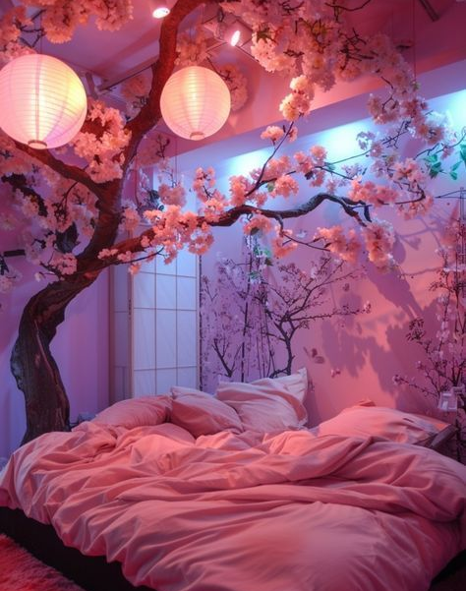
Transform Your Space with Ninja Designs!
Looking to turn your home or office into a stunning, modern masterpiece? Look no further than Ninja Designs – where every corner comes to life with pastel pink, lilac, white, gray, and beige tones. We specialize in creating spaces that feel both peaceful and inspiring.
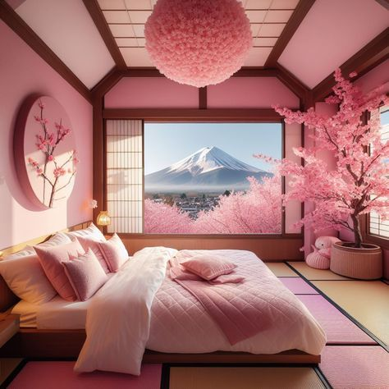
✨ Big Windows. Breathtaking Views.
Our designs focus on bringing the outside in, with spacious windows framing incredible views.
🌸 Pastel Perfection.
Pastel pink takes the center stage, creating a soft, calm ambiance that invites relaxation and creativity.
💡 Lighting That Sets the Mood.
From soft, ambient lights to statement fixtures, we ensure your space feels as beautiful by night as it does by day.

