Alaska in Pictures

Wonder Lake, Denali National Park & Preserve
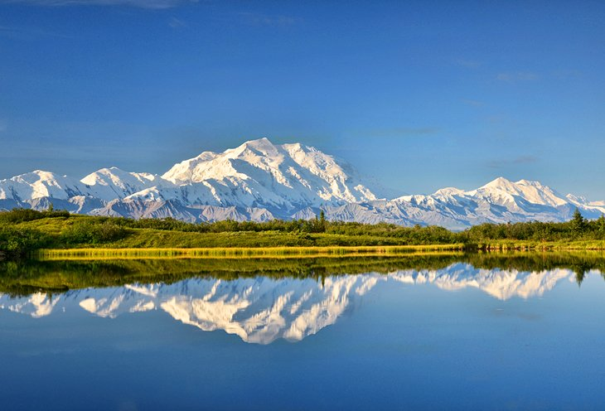

Seward Highway
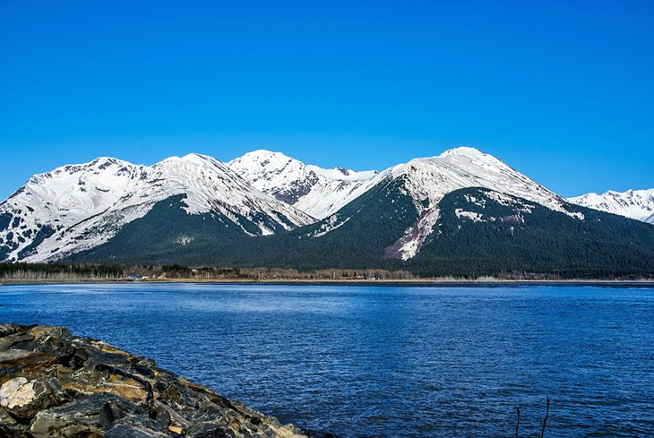

Brooks Camp, Katmai National Park and Preserve
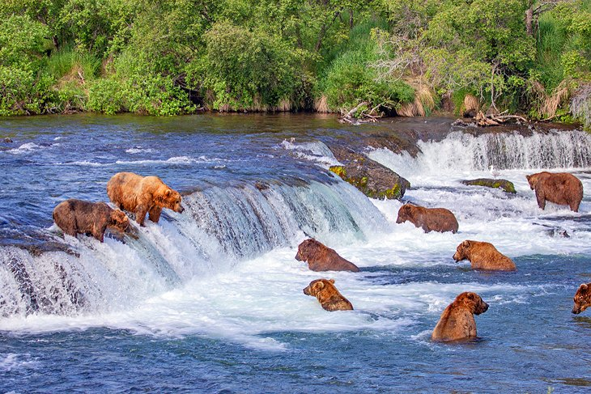

Exit Glacier, Kenai Fjords National Park
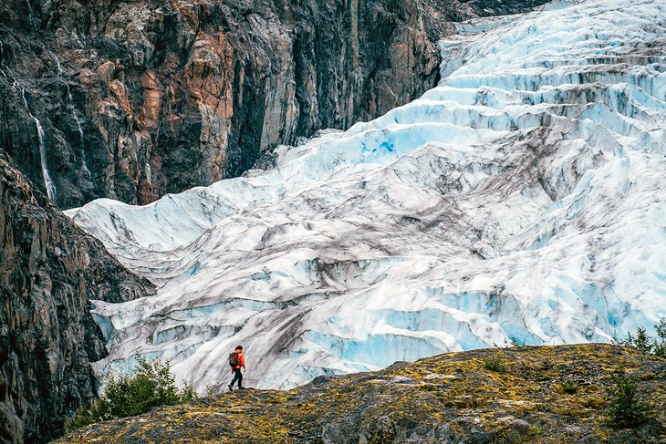

Northern Lights in Fairbanks
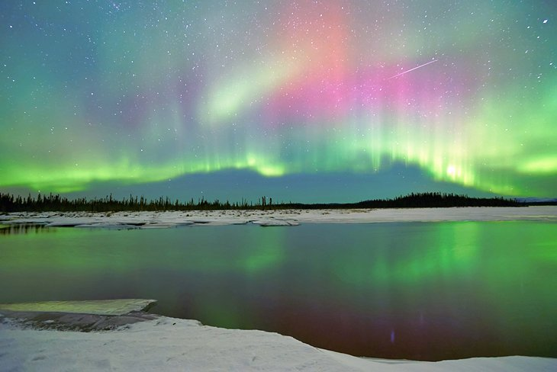

Alaska Wildlife Conservation Center, Girdwood
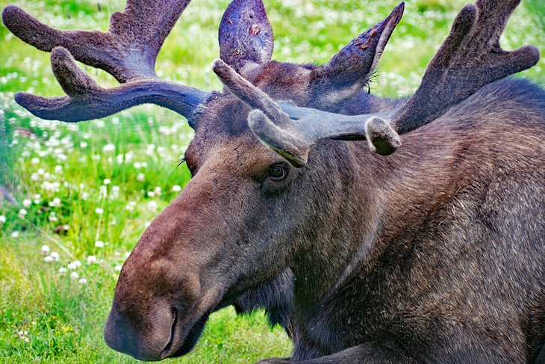

Margerie Glacier, Glacier Bay National Park and Preserve
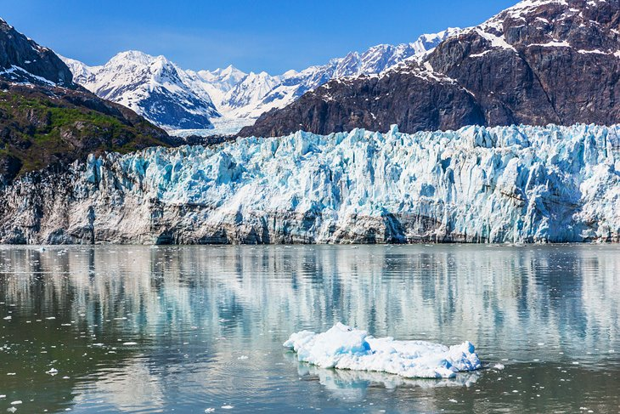

Klondike Gold Rush National Historical Park
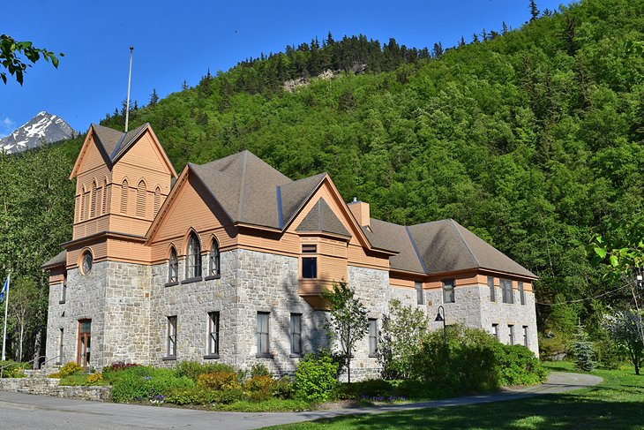

Chugach State Park, Anchorage
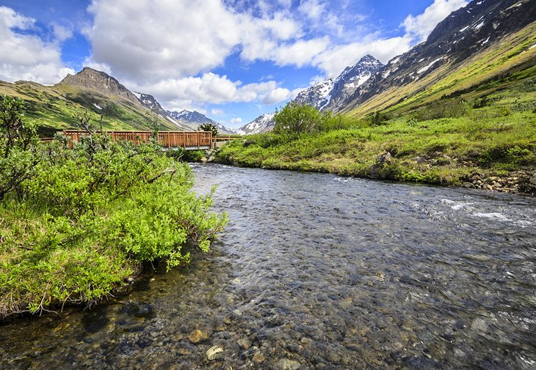

Wrangell-St. Elias National Park and Preserve
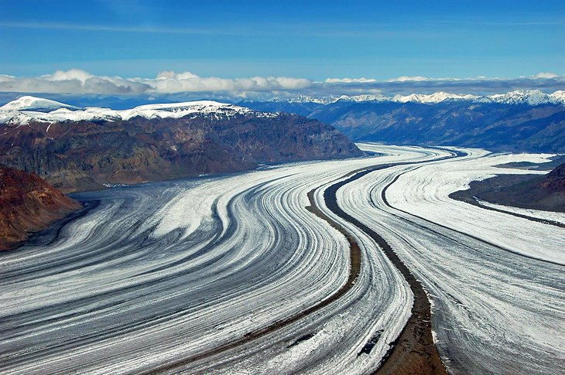

The Alaska Highway
